In this we will try to send email to the customer through ax code

1. you have to set SMTP server on your desktop

* Click Start Menu of compyter
* Go in administrator tools
* go to server manager
* click on manage
* add features and roles
* click next next
* when you come on features find smtp features click them
* Install

<https://docs.microsoft.com/en-us/dynamicsax-2012/appuser-itpro/configure-email-functionality-in-microsoft-dynamics-ax>

**Configure the SMTP server**

Use the following procedure to configure the SMTP server to use integrated Windows authentication.

1. From the **Start** menu or screen click **Administrative Tools**.
2. Click **Internet Information Services (IIS) 6.0 Manager** to open IIS Manager.
3. In the left pane, select the name of your server.
4. In the right pane, right-click **[SMTP Virtual Server #1]** and then click **Properties**.
5. The **[SMTP Virtual Server #1] Properties** window is displayed. Click the **Access** tab.
6. Click the **Authentication** button.
7. The **Authentication** window is displayed. Select the **Integrated Windows Authentication** check box. Click **OK**.
8. The **Access** tab is redisplayed. Click the **Relay** button.
9. The **Relay Restrictions** window is displayed. Select the **Allow all computers which successfully authenticate to relay, regardless of the list above** check box. Click **OK**.
10. The **[SMTP Virtual Server #1] Properties** window is redisplayed. Click **OK** to close the window.

**Connect Microsoft Dynamics AX to the SMTP mail server**

Use the following procedure to connect Microsoft Dynamics AX to the SMTP mail server.

1. Open the Microsoft Dynamics AX client.
2. Click **System administration** > **Setup** > **System** > **E-mail parameters**.
3. In the **Outgoing mail server** field, enter the name of the computer on which you installed the SMTP server.
4. In the **Local computer name** field, enter the name of the local computer.
5. In the **SMTP port number** field, enter the port number to use with SMTP. The default port number is 25.
6. If the SMTP server requires authentication, enter a valid username and password.
7. Select the **Use NTLM** check box.
8. In the **Attachment size limit (MB)** field, enter a size limit for email attachments.

The **maxbuffersize** registry key also limits the acceptable size for email attachments. If the size that you enter in this field exceeds the maximum buffer size, the maximum buffer size limit will apply.

1. In the **Allow embedded data and attached files from** field, enter or browse to the location where email attachments or other embedded data in an email is stored.

Confrigation Link: <https://intellitect.com/configuring-windows-smtp-server-on-windows-2008-for-relay/> and docomentation.

After Configuring SMTP with the server and ax2012

1. Go to Orgizational Administrator
2. Go to Setup and than Email Template Build Template here
3. After this go to System Administrator Email Parameters

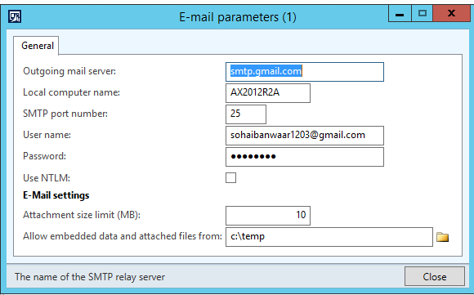

This is the email Parameters. Now go into the job and write this cod

In this we will try to send email to the customer through ax code

1. you have to set SMTP server on your desktop

* Click Start Menu of compyter
* Go in administrator tools
* go to server manager
* click on manage
* add features and roles
* click next next
* when you come on features find smtp features click them
* Install

<https://docs.microsoft.com/en-us/dynamicsax-2012/appuser-itpro/configure-email-functionality-in-microsoft-dynamics-ax>

**Configure the SMTP server**

Use the following procedure to configure the SMTP server to use integrated Windows authentication.

1. From the **Start** menu or screen click **Administrative Tools**.
2. Click **Internet Information Services (IIS) 6.0 Manager** to open IIS Manager.
3. In the left pane, select the name of your server.
4. In the right pane, right-click **[SMTP Virtual Server #1]** and then click **Properties**.
5. The **[SMTP Virtual Server #1] Properties** window is displayed. Click the **Access** tab.
6. Click the **Authentication** button.
7. The **Authentication** window is displayed. Select the **Integrated Windows Authentication** check box. Click **OK**.
8. The **Access** tab is redisplayed. Click the **Relay** button.
9. The **Relay Restrictions** window is displayed. Select the **Allow all computers which successfully authenticate to relay, regardless of the list above** check box. Click **OK**.
10. The **[SMTP Virtual Server #1] Properties** window is redisplayed. Click **OK** to close the window.

**static** **void** Sohaib_Email(Args _args)

{

SysEmailTable sysEmailTable;

Map mappings = **new** Map(Types::String, Types::String);

*// str xml;*

;

*// Build your variable/text mappings*

mappings.insert('subject', 'My Subject Here');

mappings.insert('word1', 'This replaces word1');

mappings.insert('word2', 'This replaces word2');

mappings.insert('body', 'This will replace body with this string and this ' +

SysLabel::labelId2String(**literalstr**('@SYS25058'), 'en-us'));

mappings.insert('TheseCanBeAnythingYouWant', 'More text');

sysEmailTable = SysEmailTable::find('Sohaib');

*/\**

*// If you were using XSLT, here is an example of how to build the XML*

*// but you would most likely create your own static method*

*xml = EventActionEmail::createEmailParameterXml(mappings);*

*\*/*

SysEmailTable::sendMail(sysEmailTable.EmailId,

'en-us', *// Chosen language*

'SohiabAnwaar36@gmail.com', *// Who you're sending the email to*

mappings, *// Your variable mappings*

'', *// Location of file attachment (server/client matters) or none*

'' , *// XML if you're using XSLT*

**true**, *// Traceable or not?*

'Sohaib Anwaar', *// Sending user*

**true**); *// Use retries?*

info("Email Send");

}

Now if the Email Send InfoLog come now check the status of the email.

1. Go to System Administrator
2. Go to Periodic
3. Go to Email Send Status.
4. Check Email Status Here